ASSIGNMENT-2

Here, we are using share point online for website creation. First we have to create one site I.e., assignment.

Login with our id and go to the <https://maneeshachebrolu.sharepoint.com/_layouts/15/sharepoint.aspx>.

Here we have to fine option like create site.

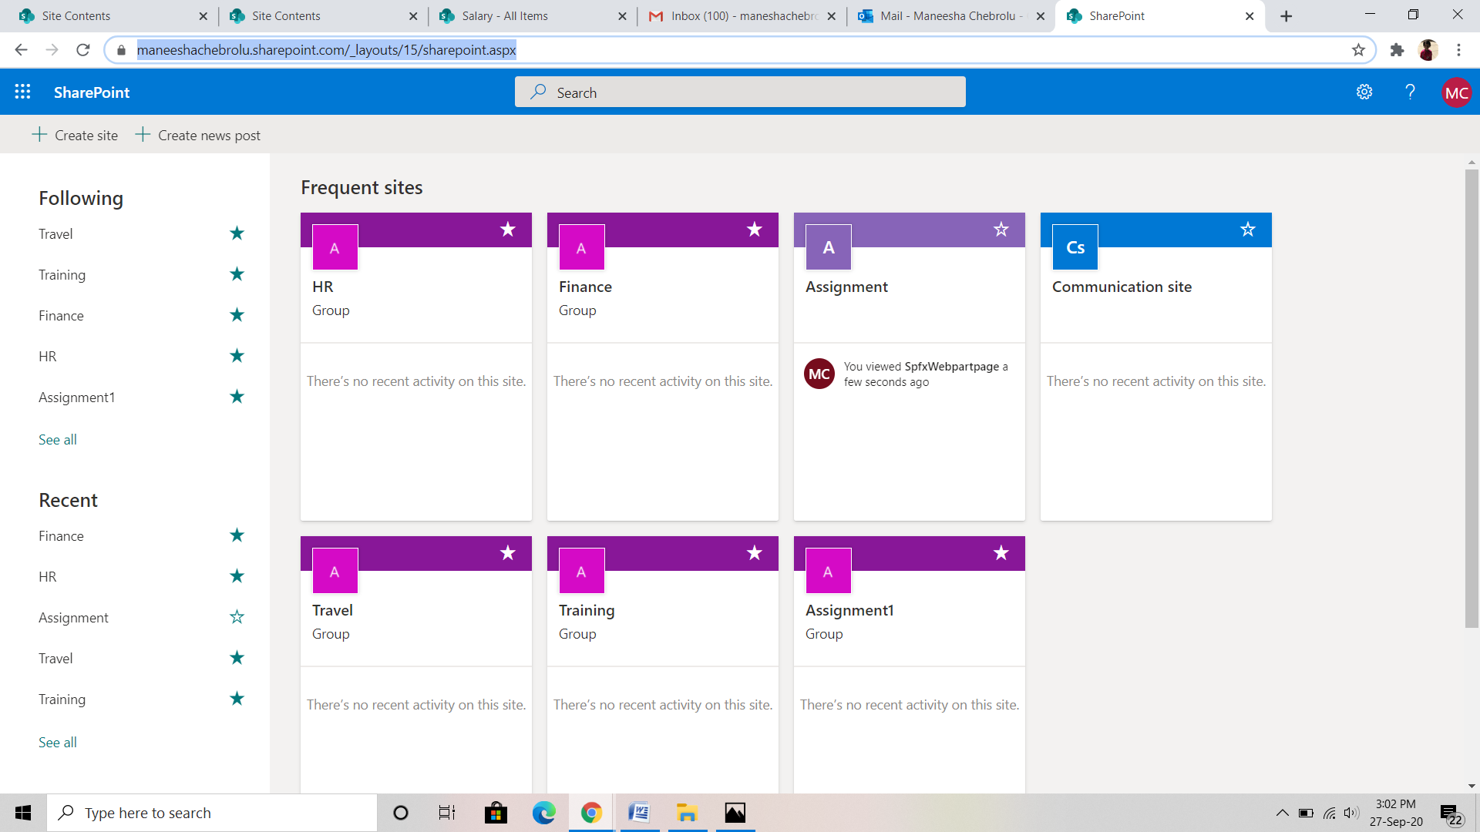

Here I have created four sub sites with in assignment site ie., HR, Finance, Travel and Training.

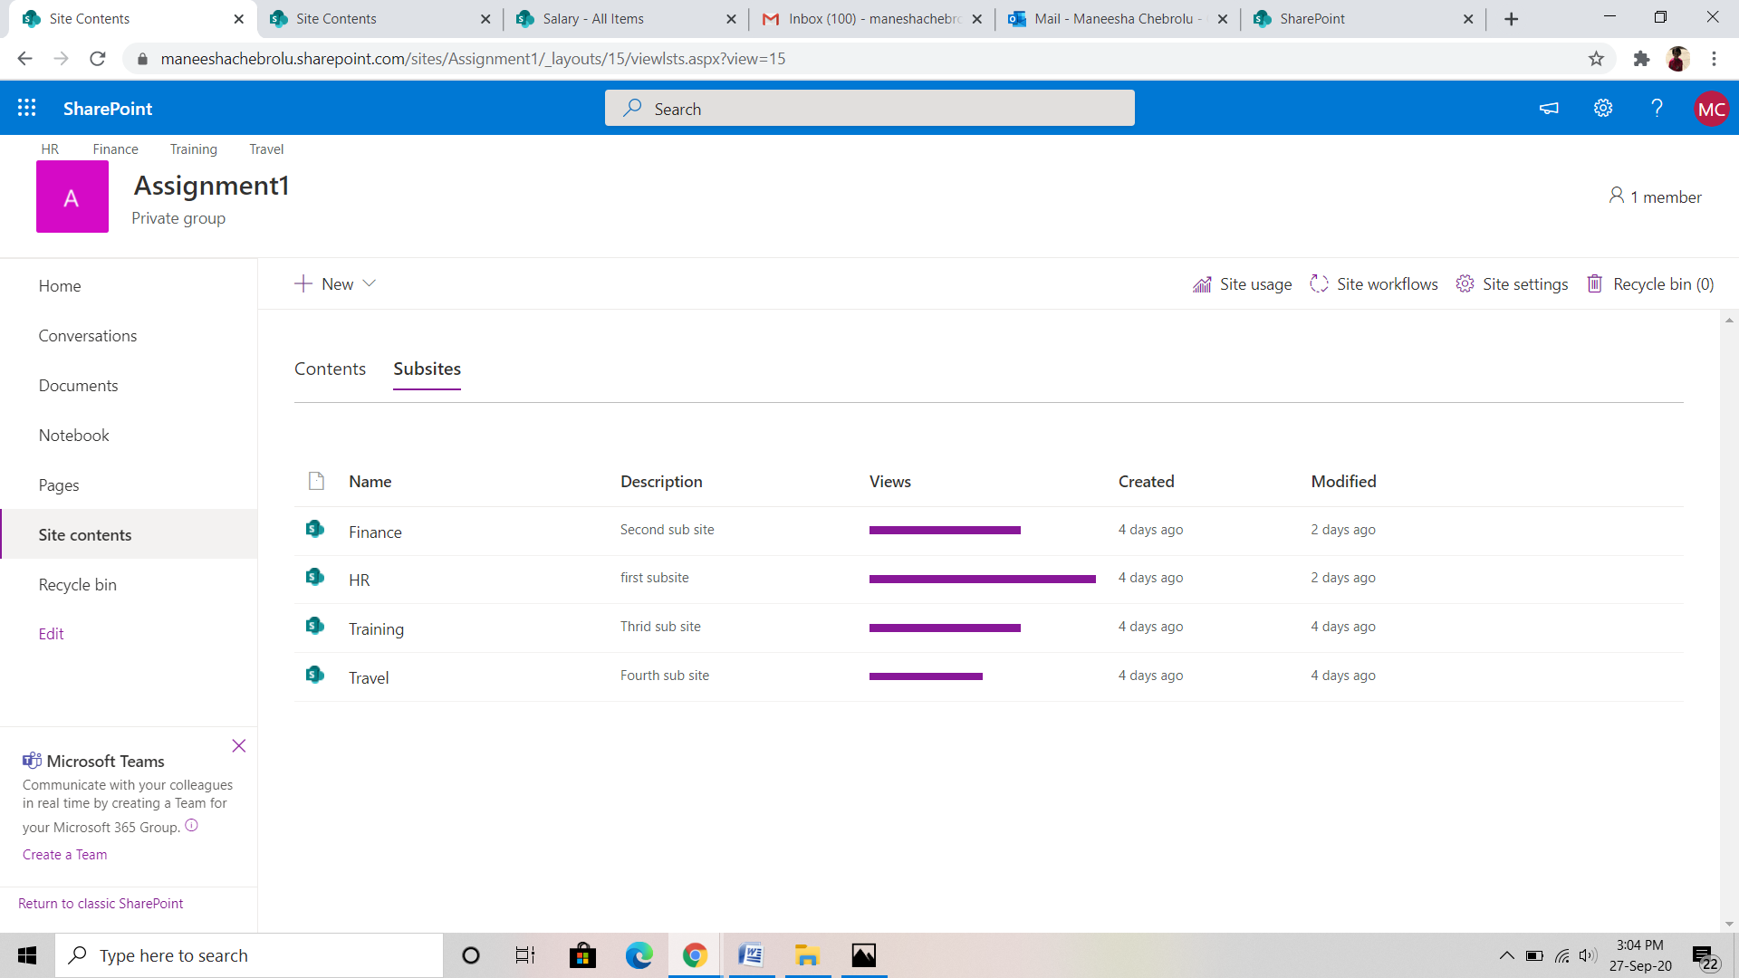

**TASK-1: IN HR SUB SITE**

**HR Site,** add validation that the designation can be changed only to higher level. (Use Pre Save Action for validation)

In HR sub site, create a list named as “Designation”

Home->New->List.

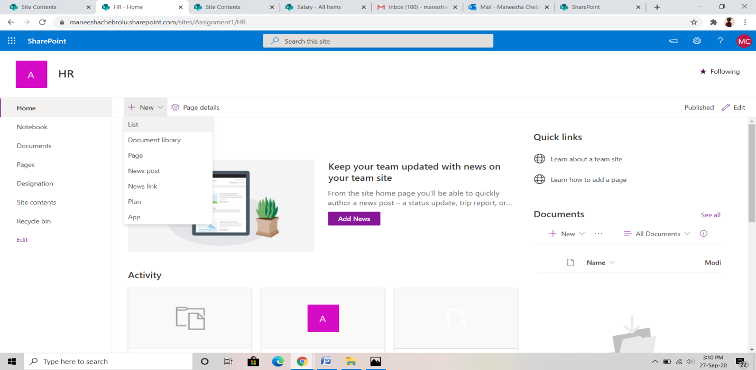

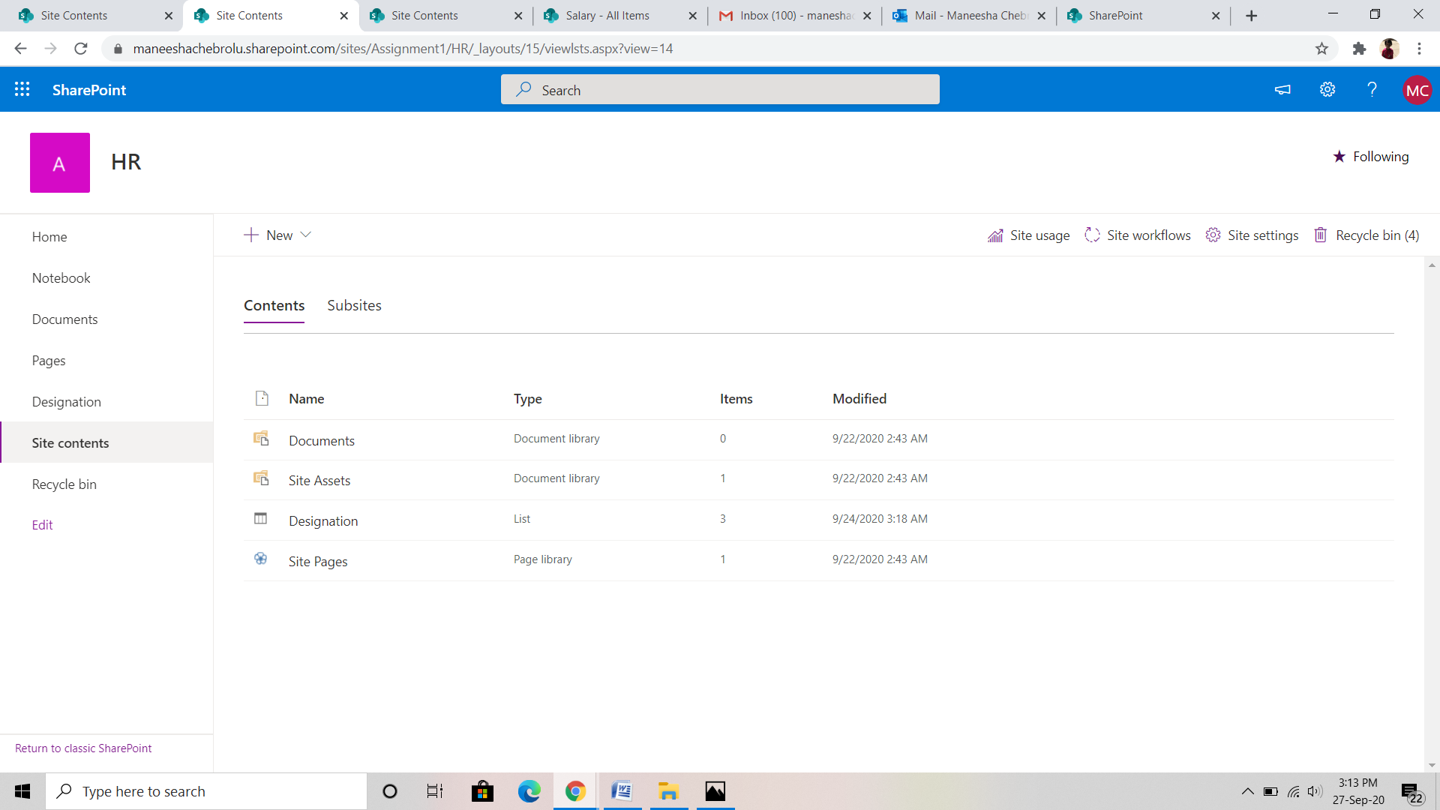

Add some columns in designation list like Name, Designation and Designation when joined.

Designation and Designation when joined has to take some choosing options like

Designation List:

·       ELT-Entry Level Trainee

·       PAT-Programmer Analyst Trainee

·       A-Associate

·       SA-Senior Associate

·       M-Manager

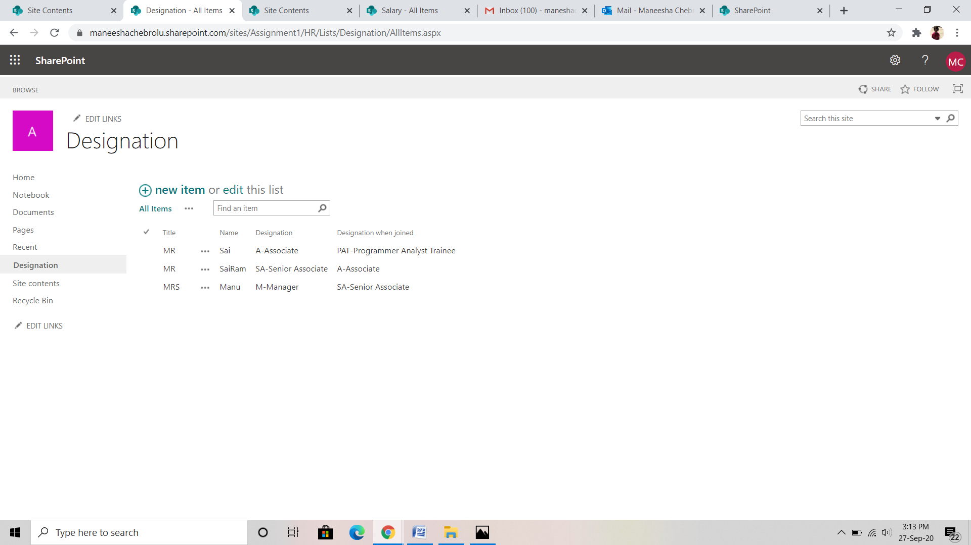

The main task is to create validations for Designation and designation when joined columns. For that validations we have to add web part and script editor.

Go to edit page -> Add web part->media and contents->script editor->Edit snippet.

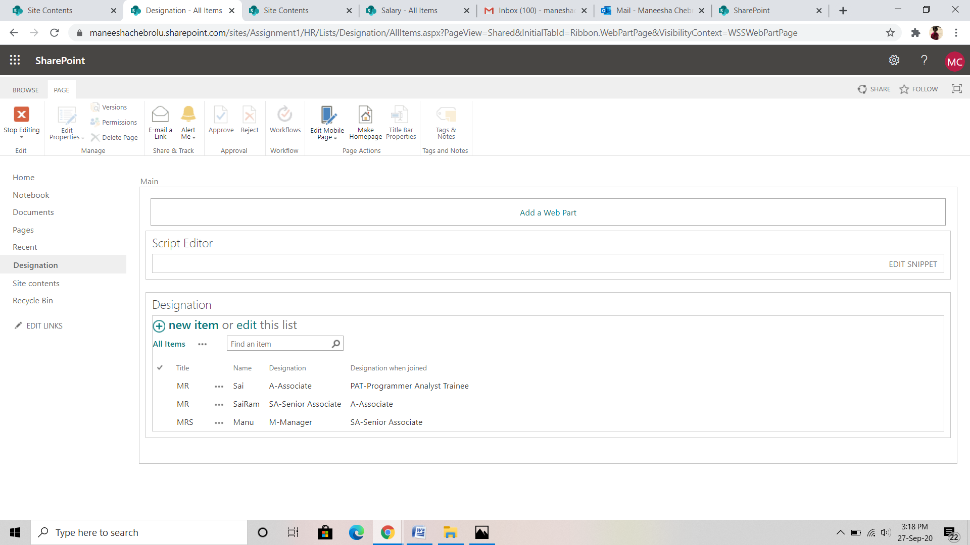

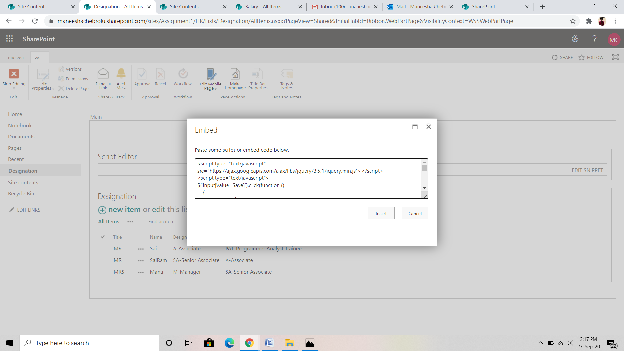

Here insert the java script code for validations.

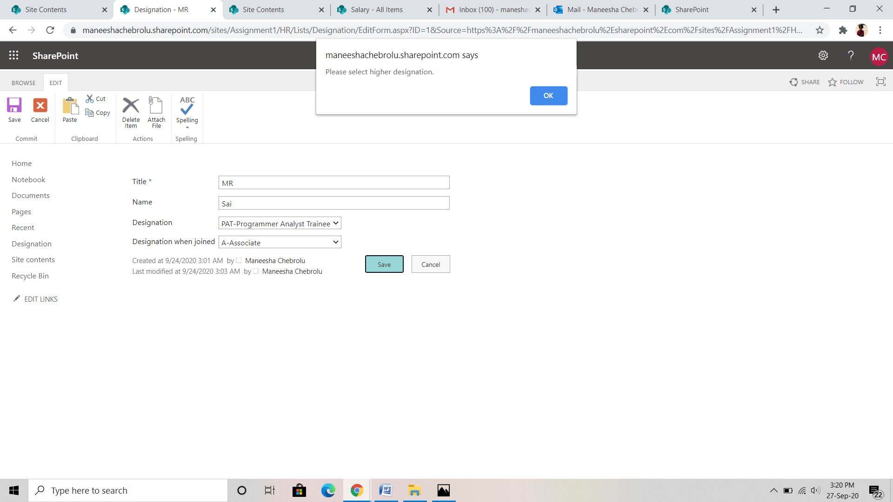

Validations are working.

**TASK-2: IN FINACE SUB SITE**

**Finance Site,** add validation that the current salary of the employee is within the range of the current designation (to be taken from HR Site) of the employee – Requirement 1

(Allow, saving of data, use workflow to validate, if exceeds set the salary to the maximum limit, if less than minimum limit, set it as minimum value) - Requirement 2

|  |  |  |
| --- | --- | --- |
| Designation | Minimum Limit | Maximum Limit |
| ELT | 10,000 | 20,000 |
| PAT | 25,000 | 40,000 |
| A | 45,000 | 60,000 |
| SA | 65,000 | 80,000 |
| M | 85,000 | 1,00,000 |

In task 2 we have to full fill 2 requirements.

Create salary list in finance sub site. Home->New->List.

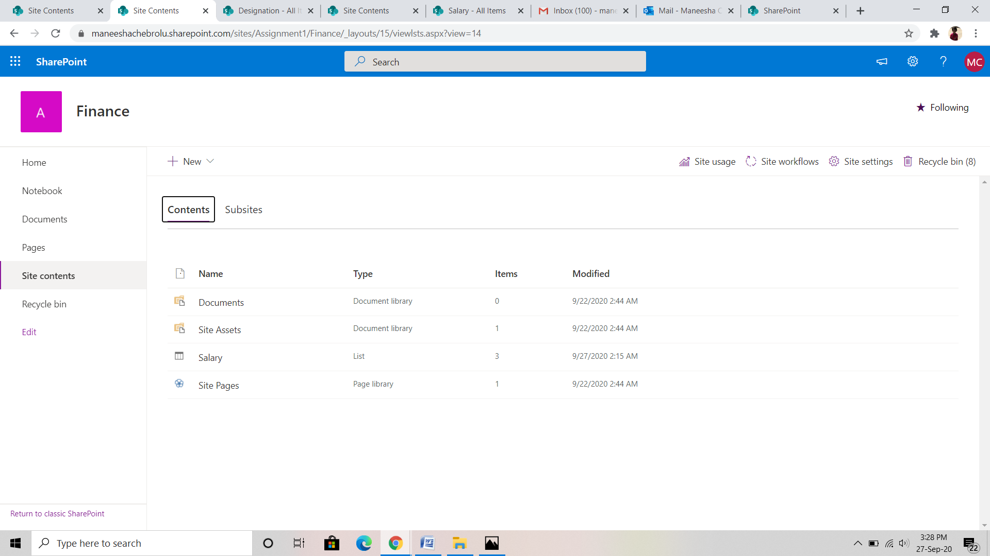

Here, also create some columns like employee name designation, designation when joined, minimum salary, maximum salary, employee id.

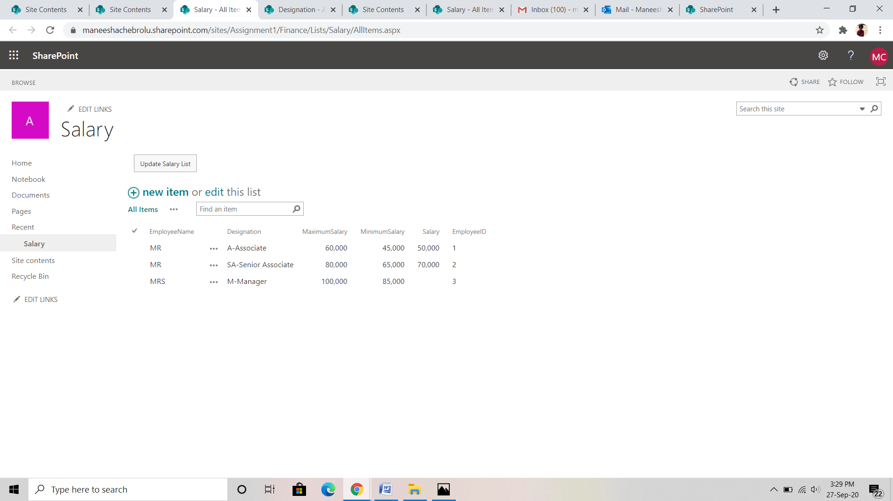

Here also add web part and script editor to perform validations.

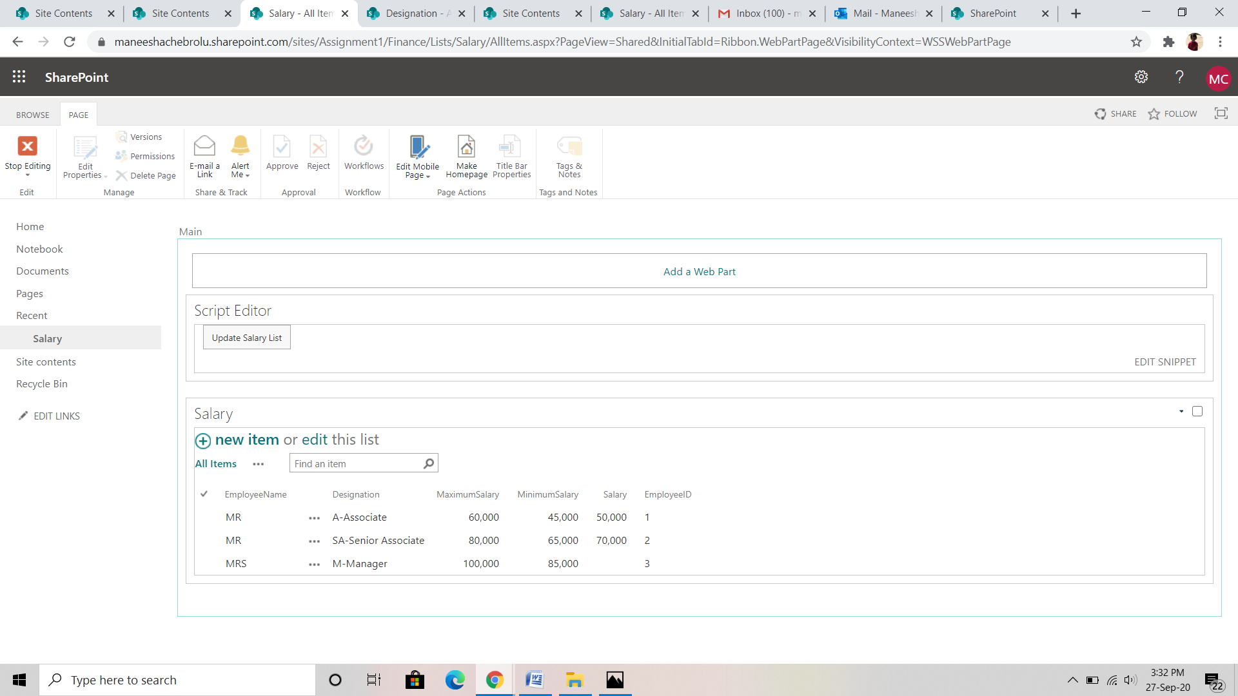

Create a “button” update salary list and method get all items called when we click the button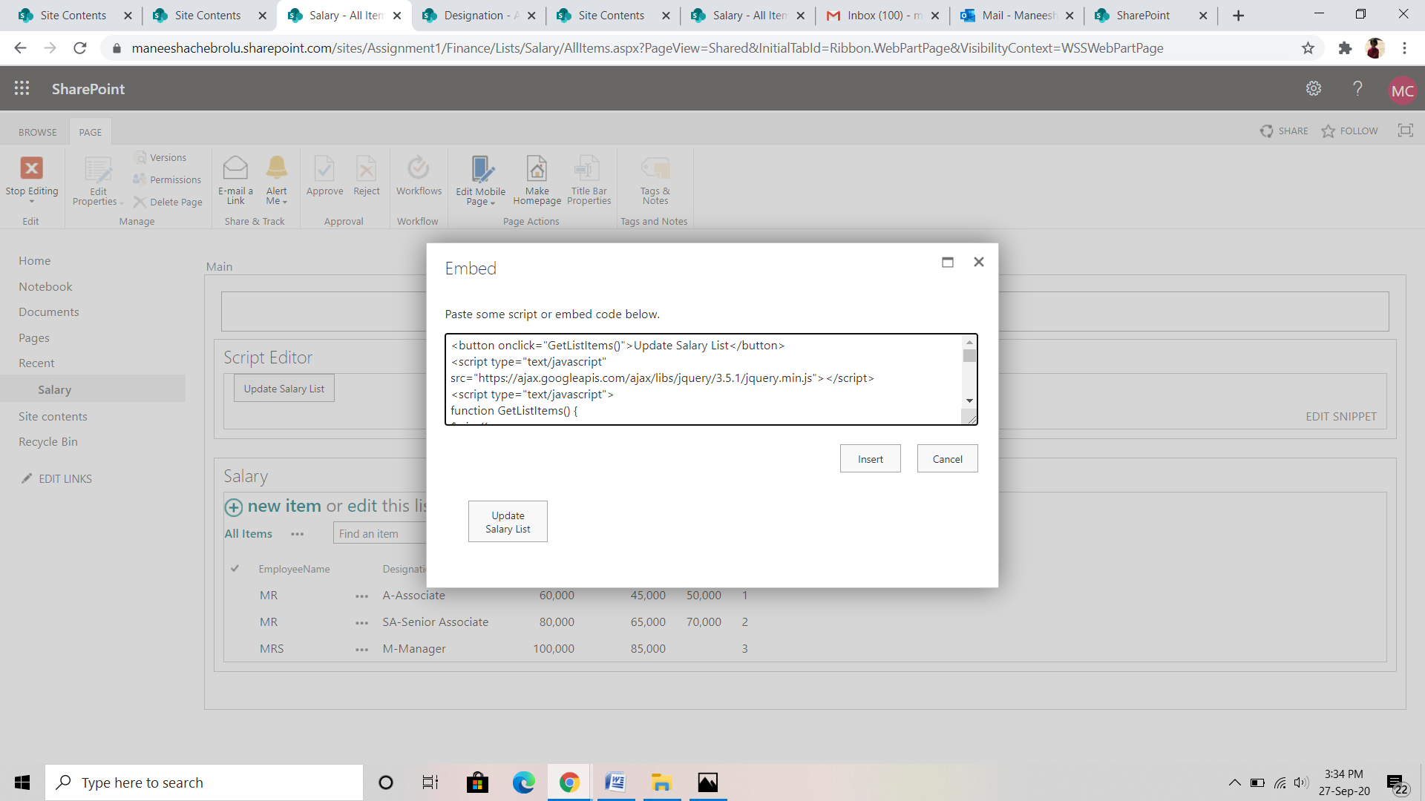

When we click the button “update salary list” the employee details present in hr sub site are updated in finance sub site with minimum and maximum salary limit we are given in the code.

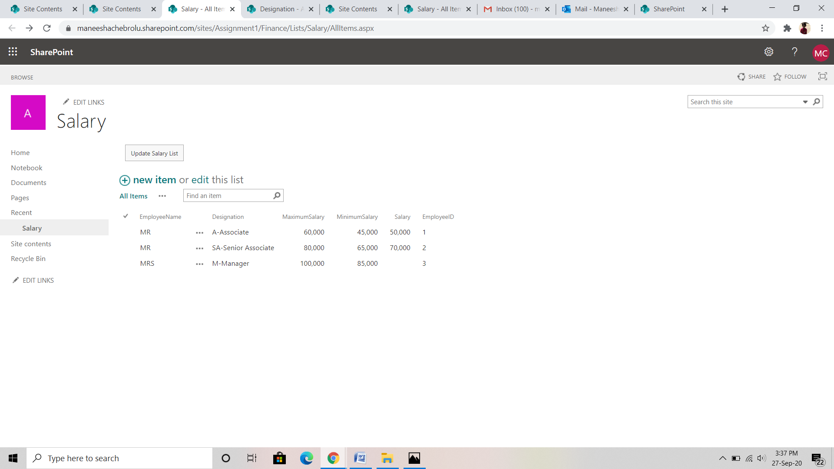

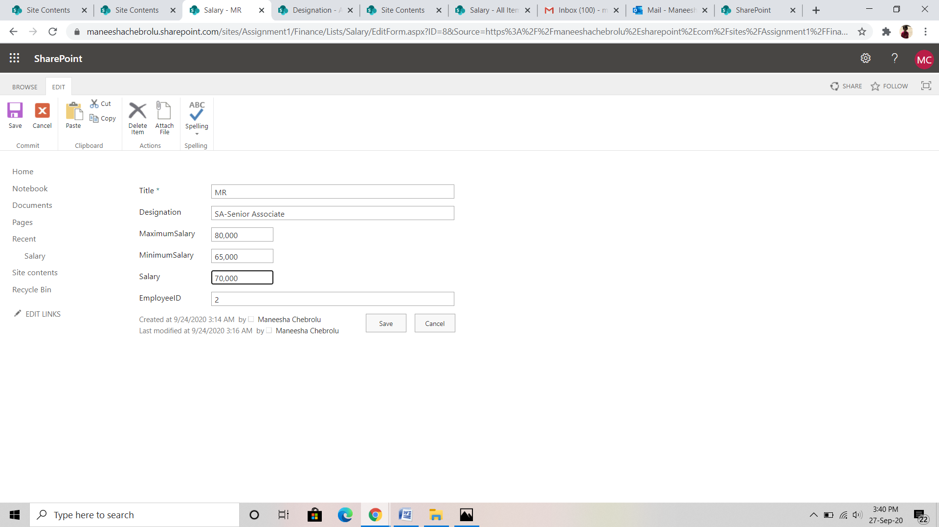

Then we have enter the salary with in the limit provided in the fields.

Else it gives an error msg.

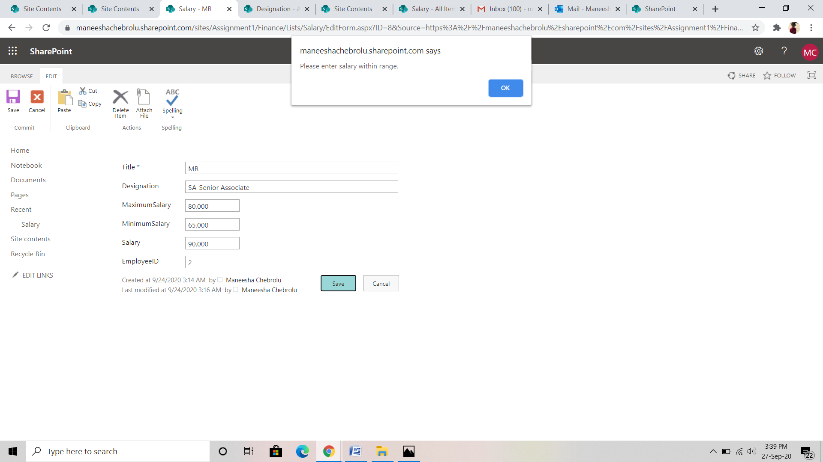

**TASK-3: SPFx COMPONENT**

   Travel Request cannot be made by a person, which results in conflict. (Build using SPFx component)

Create a directory for SPFx solution

md TravelRequests

Navigate to above created directory

cd TravelRequests

Run Yeoman SharePoint Generator to create the solution

yo @microsoft/sharepoint

To preview the web part

gulp serve

url to open out work bench

<https://maneeshachebrolu.sharepoint.com/sites/Assignment1/Travel/_layouts/15/workbench.aspx>

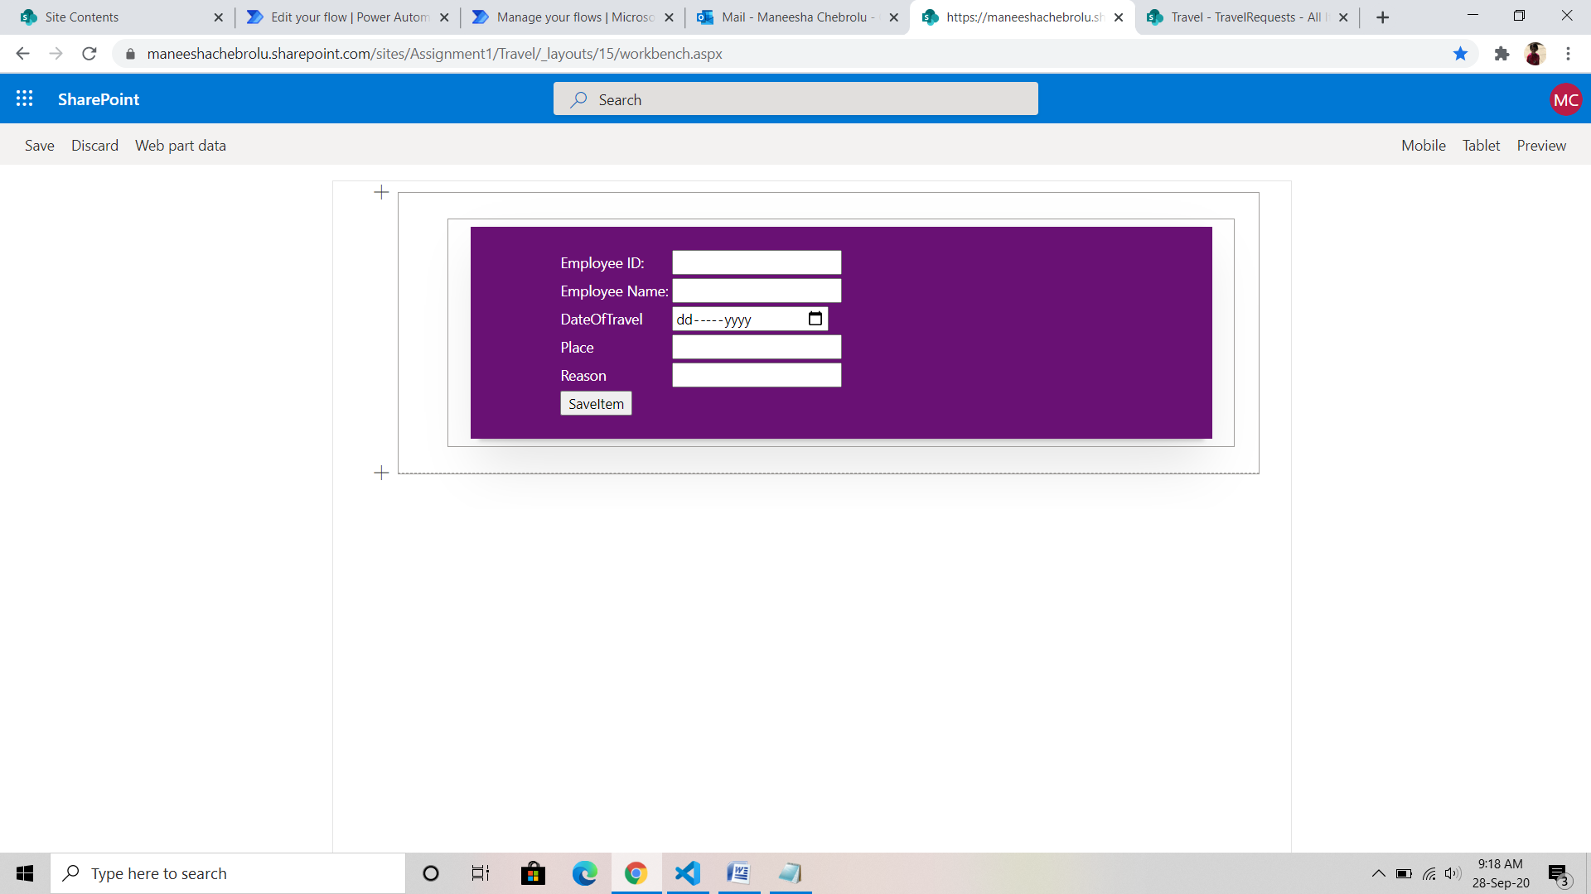

This is the way how our work bench page is opened.

Validations when no item is added.

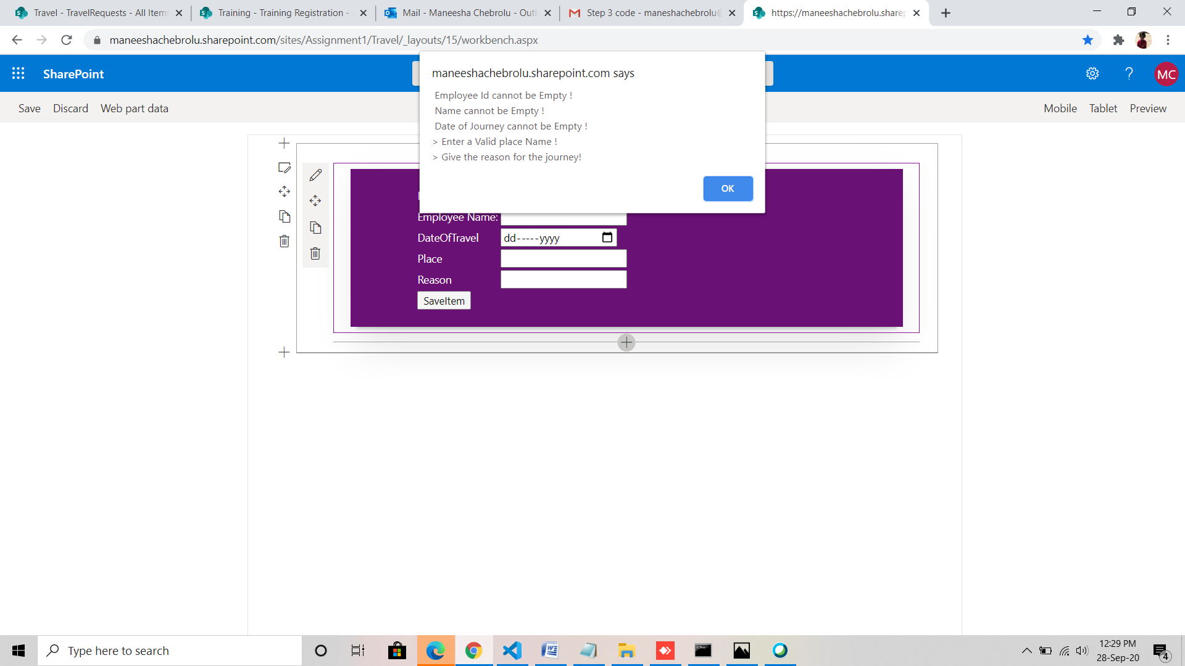

Item added using work bench

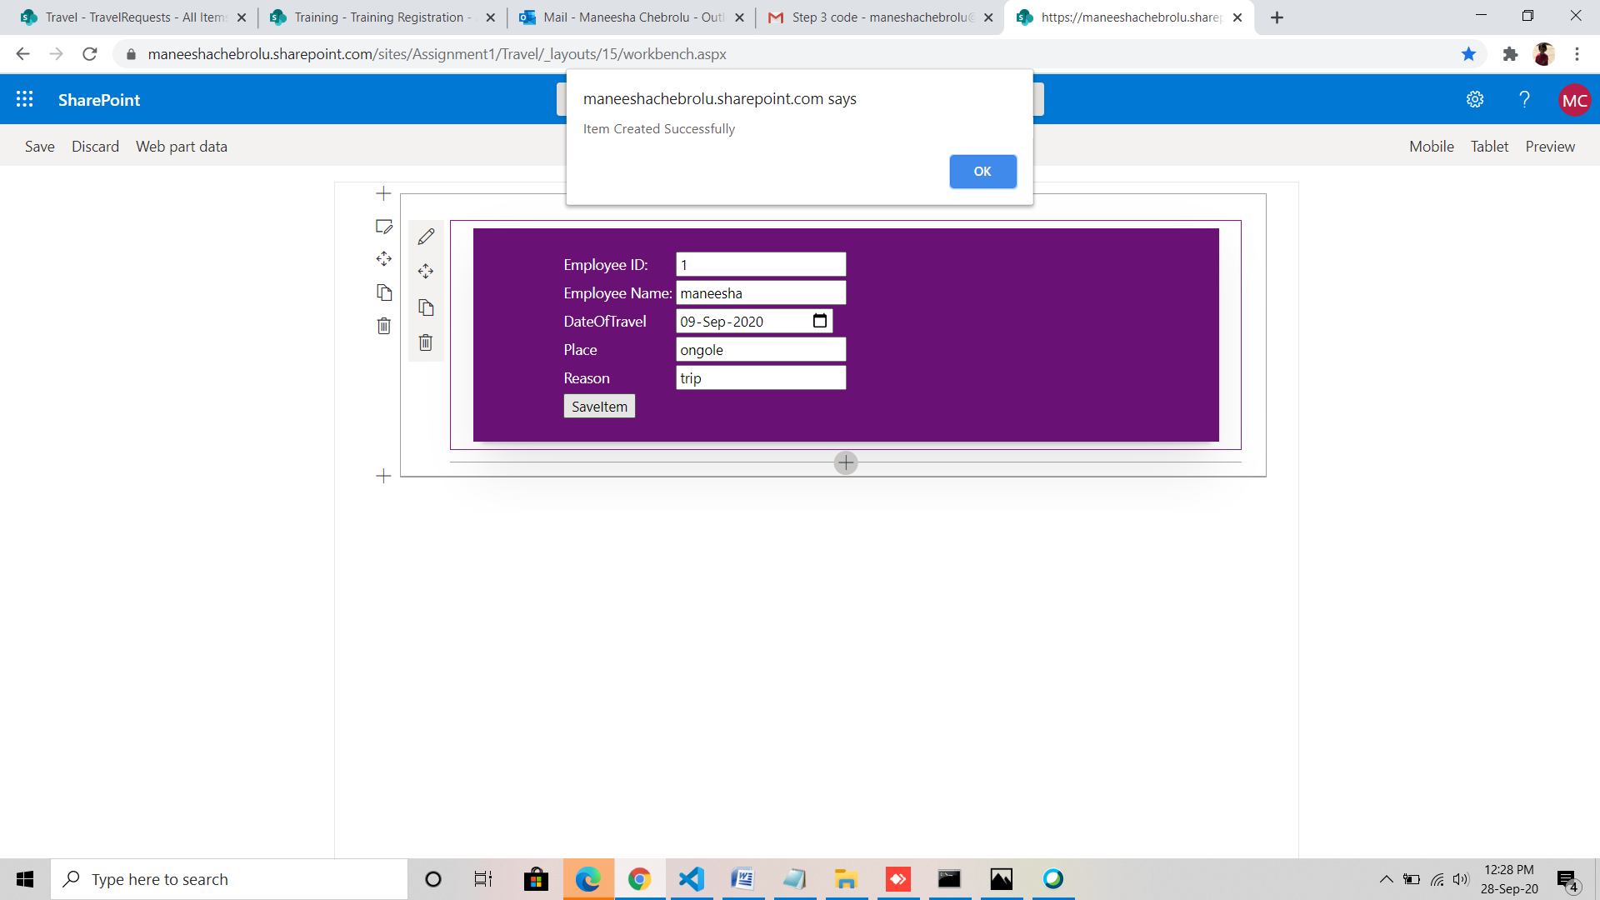

That the item is added to our sub site Travel

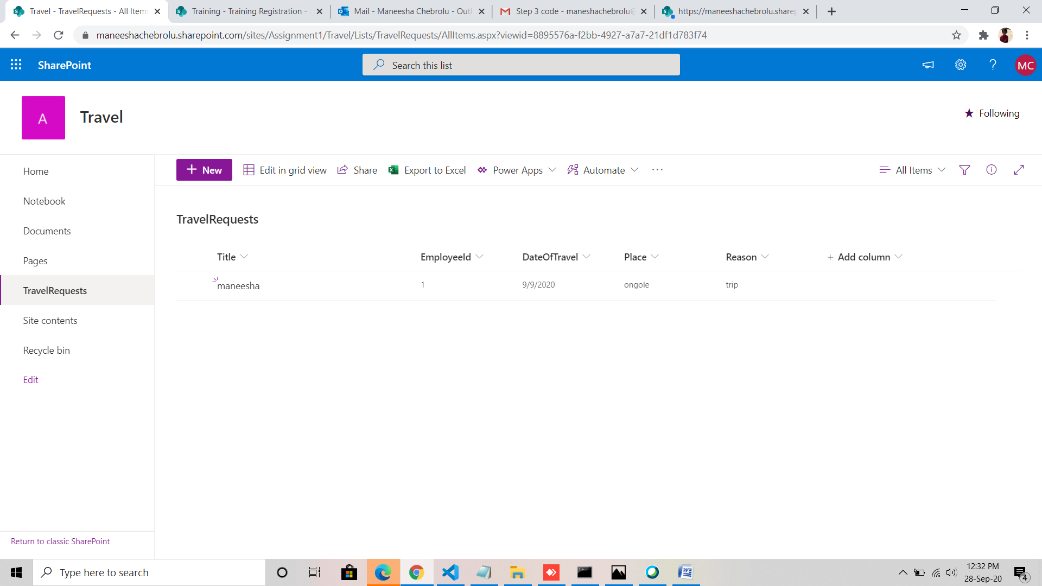

**TASK-4: WORK FLOW**

On Registration send an email for registration, assign a task to complete the training. (Build using Workflow)

Frist we have to create a list named ‘Registration’ and add some columns like status, email id, name, Id…

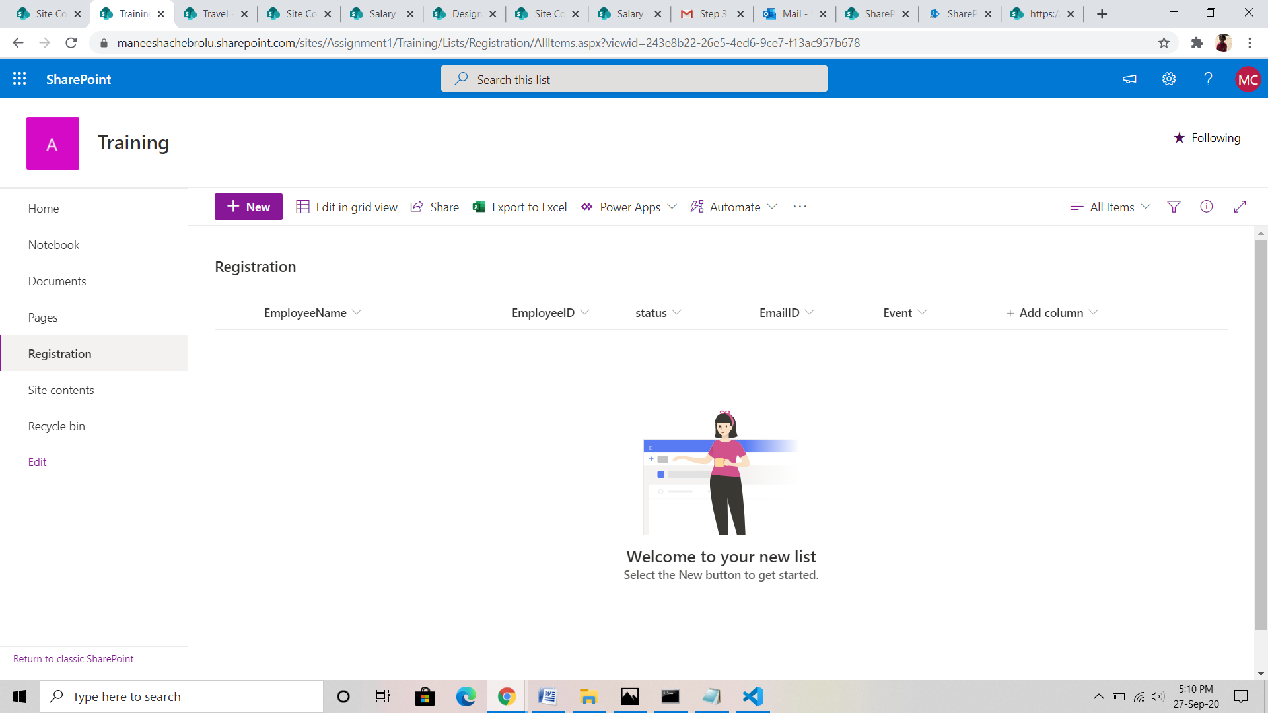

To create a flow go to automate->power automate->create flow.

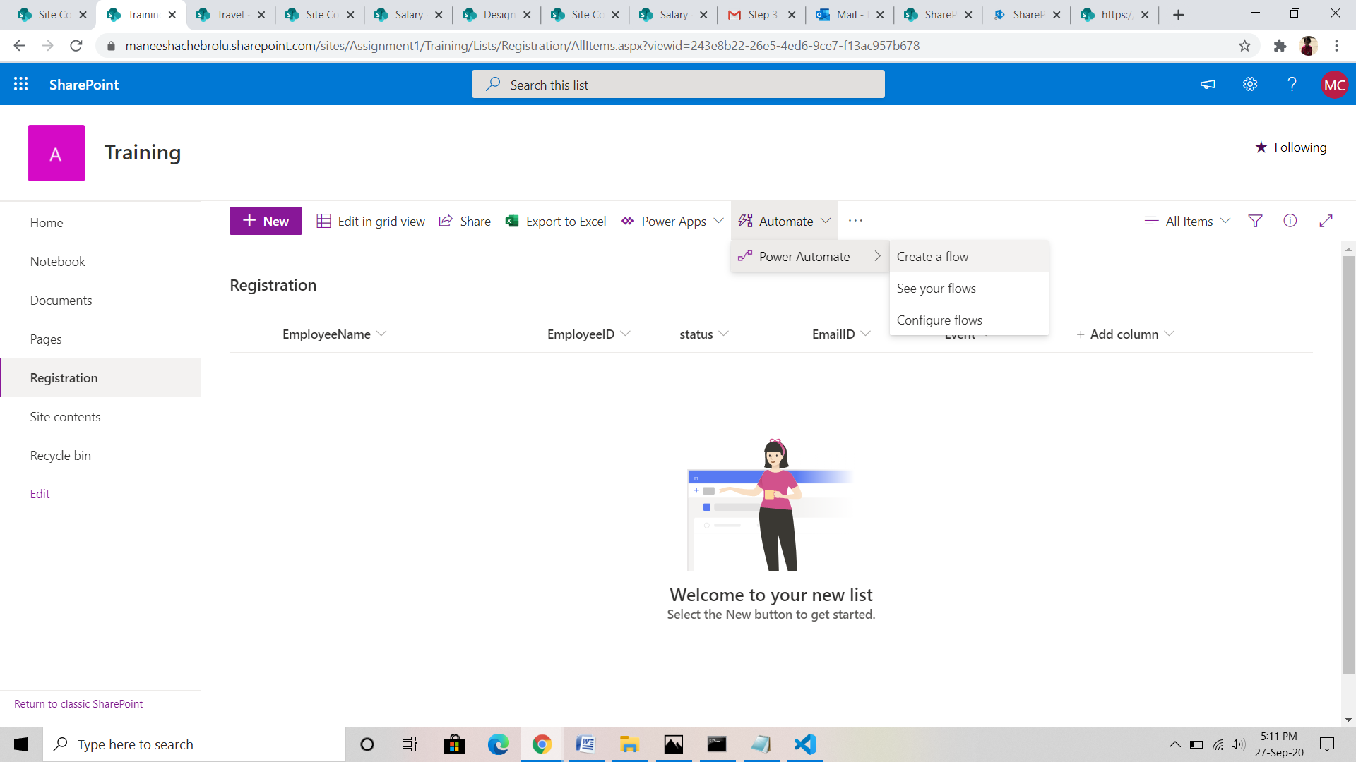

Work flow page is opened like

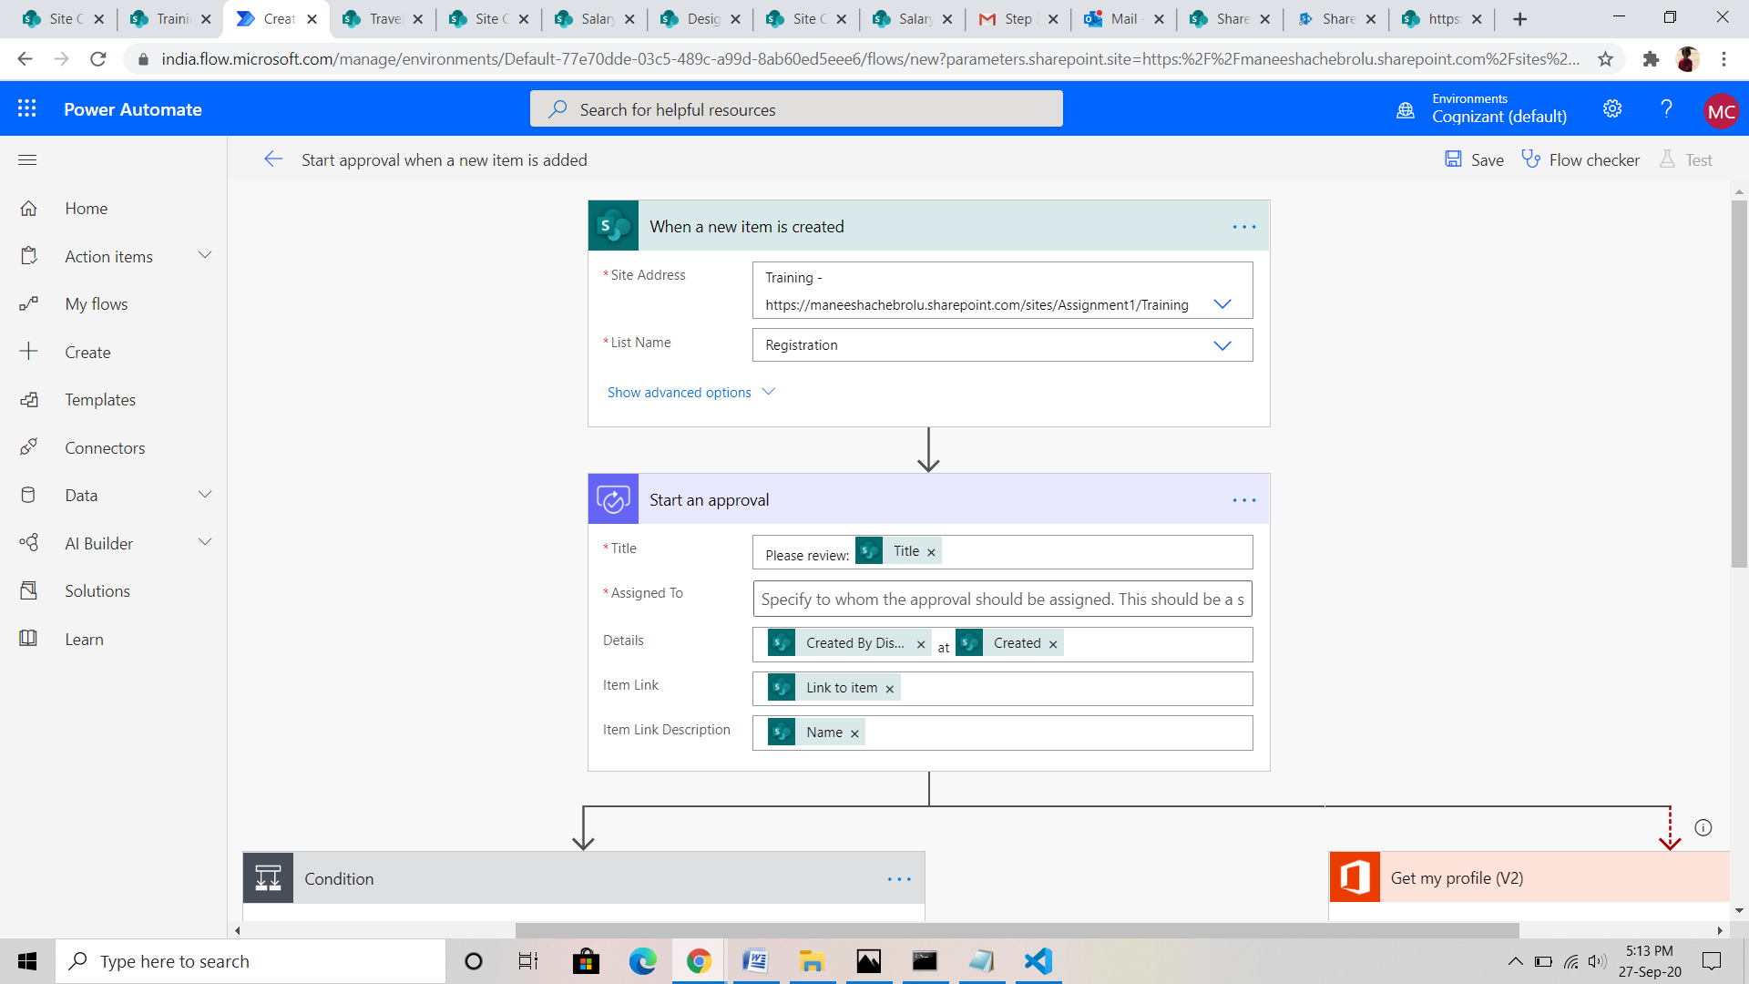

Add update item and create a flow for approve and reject.

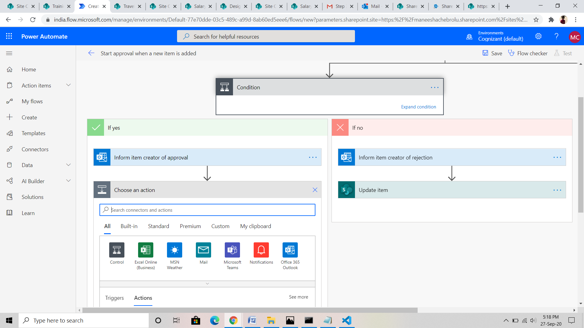

Then we get the mail like to start an action.

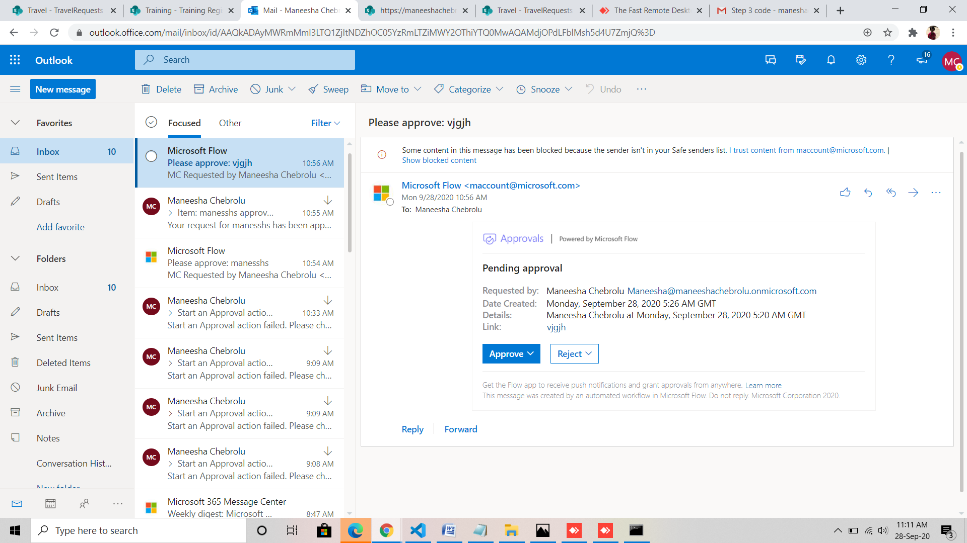

The request has been approved

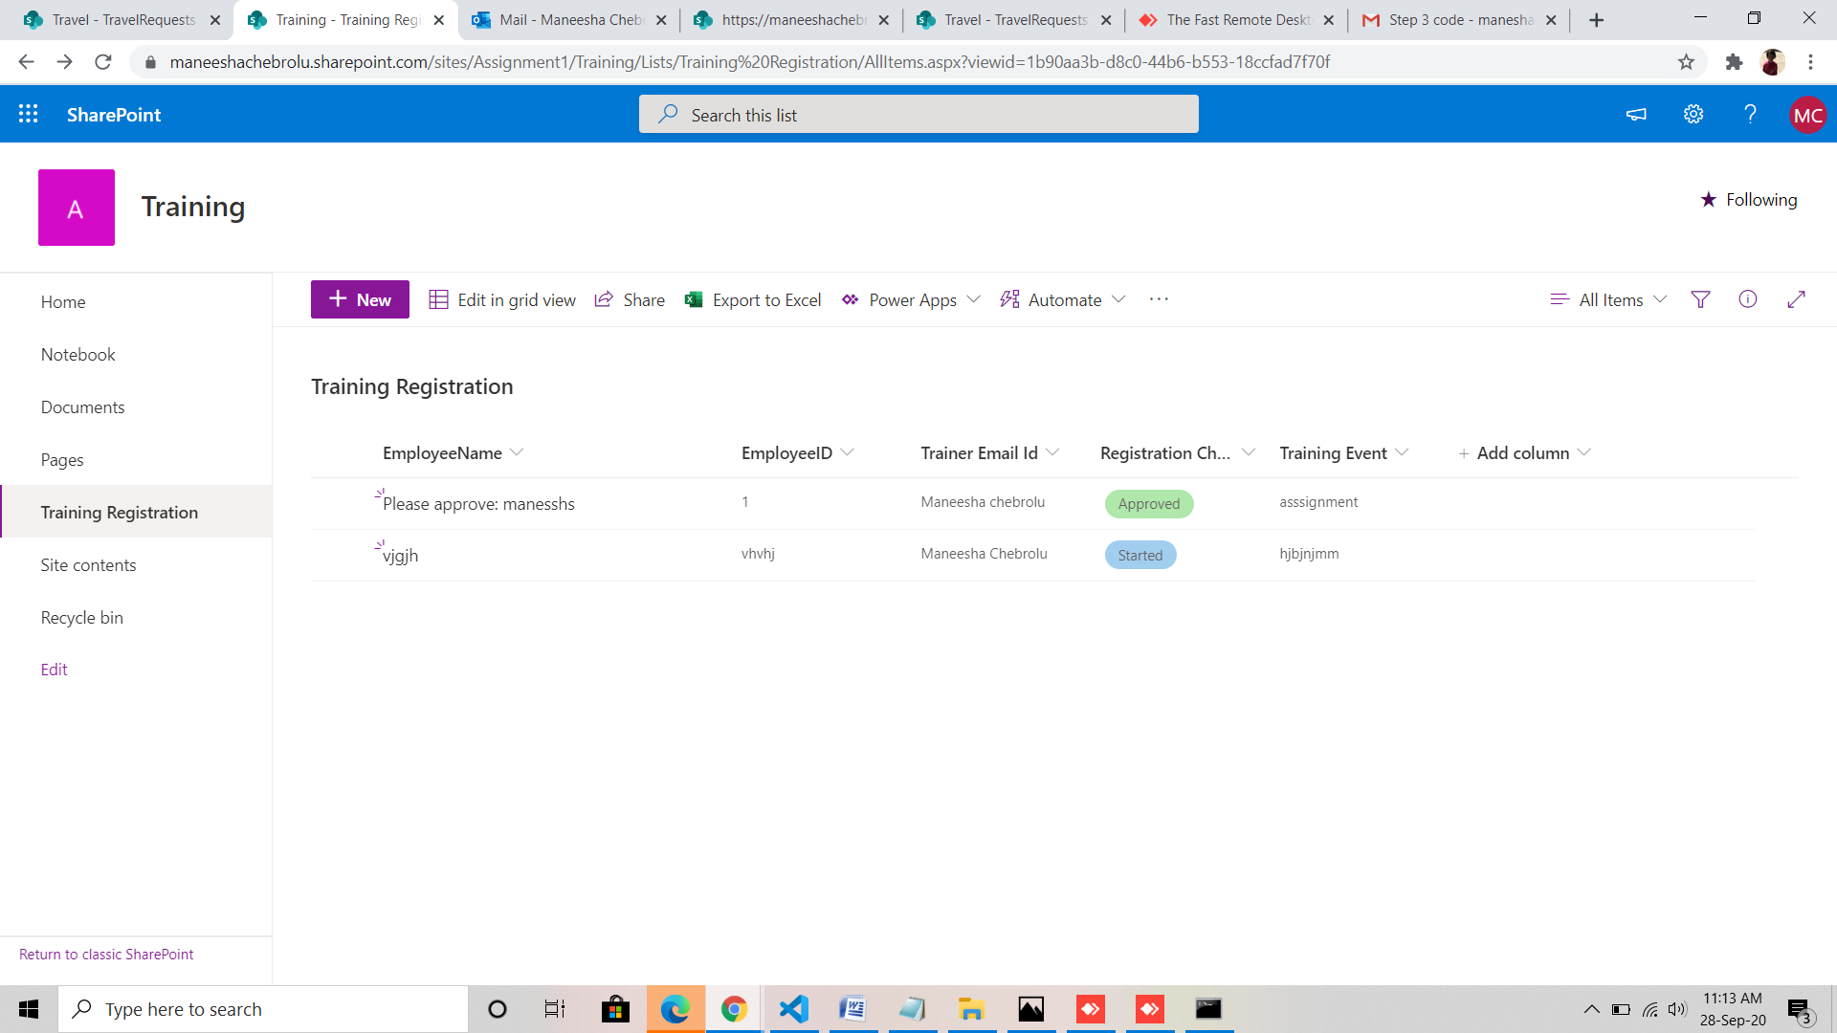

There we have approved and rejected the action

